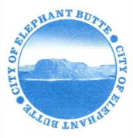
NOTICE OF PUBLIC HEARING
ORDINANCE NO. 205

Notice is hereby given that Ordinance 205 will be presented for Public Hearing on Wednesday, October 19, 2022, at the regularly scheduled City Council Meeting at 2 pm. The city will make its meetings open to the public at 103 Water Ave. Elephant Butte, NM 87935.

Ordinance 205 is an ordinance establishing conditions for storage facilities withing the City of Elephant Butte.

This ordinance can be reviewed in its entirety at City Hall, 103 Water Street, from 8 am -12 pm and
1 pm – 5 pm Monday through Friday or on the City’s website www.cityofelephantbutte.com.

Jessica Newberry
City Clerk

Posted: September 23rd, 2022

