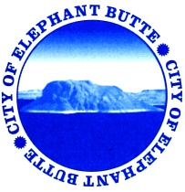
NOTICE OF CITY OF ELEPHANT BUTTE SPECIAL CITY COUNCIL MEETING
OPEN TO THE PUBLIC
Monday, December 18, 2017
Municipal Building – 103 Water Street
DRAFT
COUNCIL AGENDA – 2:00pm

- CALL TO ORDER
- ROLL CALL
  - Mayor Eunice Kent
  - Mayor Pro-Tem Kim Skinner
  - Councilor Gerald LaFont
  - Councilor Dee Rogers
  - Councilor Edna Trager
- APPROVAL OF AGENDA - Council Declaration of Conflict of Interest
- EXECUTIVE SESSION
  - NMSA1978 10-15-1(H)(2) Limited personnel matters; Fire Chief & Code Enforcement
- Discussion/Possible action regarding Fire Department and Code Enforcement Personnel
- ADJOURNMENT

