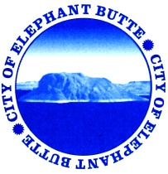
NOTICE OF CITY OF ELEPHANT BUTTE SPECIAL CITY COUNCIL MEETING
OPEN TO THE PUBLIC
Monday, June 27, 2016, 10:00am
Municipal Building – 103 Water Street

COUNCIL AGENDA – 10:00am

- CALL TO ORDER AND PLEDGE OF ALLEGIANCE
- ROLL CALL
Mayor Eunice Kent
Mayor Pro-Tem Kim Skinner
Councilor Gerald LaFont
Councilor Dee Rogers
Councilor Edna Trager
- STATEMENT OF OPEN MEETINGS RESOLUTION & THREE MINUTE LIMIT PER SPEAKER ON ALL ISSUES

- EXECUTIVE SESSION
  - NMSA 10-15-1(H)(2) Limited Personnel Matters; Code Enforcement Officer

- ADJOURNMENT

